Benjamin Russell High School
Senior Parking Spot Painting

Seniors may purchase a parking permit for $30.00 with drivers’ license and proof of insurance. In addition, seniors may purchase a permit to paint their purchased parking spot for an additional $30. Both the parking permit and paint permit may be purchased online on the BRHS Lean Stream website. Click parent tab, then lean stream. Parking permits are under “fees” and paint permit is under “marketplace.” Choose school and add to cart to pay.

What you need to paint your parking spot:
- Purchase a parking permit from Lean Stream or direct payment to Mr. McGhee.
- Purchase a paint permit from Lean Stream or direct payment to Mr. McGhee.
- Complete this form with your design prior to painting your parking spot.
- A copy of your design must be turned in for approval prior to painting. If approved, you will receive an email from Mr. McGhee or other administrators. Take a picture of your design.
- The design may not exceed the parking spot outline. You must paint within an 8” border of the parking spot lines and number.
- It must be school appropriate and follow the guidelines.
- You must follow the approved design EXACTLY on the painting day-NO CHANGES.
- Paint can only be water-based exterior latex (no spray, reflective or fluorescent permitted).
- You must provide your own paint (consider sharing with others).
Prohibited:
- No offensive language, pictures, or symbols
- No controversial or inappropriate political or social comments, symbols, etc…
- No negative or rude language (Be Kind!)
- No double-Entendre’s (double meanings)
- You may use your name but “nicknames” must be approved. No boyfriend or girlfriend’s name is allowed. It’s your parking spot, it’s about you, not others.
- Prohibited items will be covered by administration. No refunds.
- Disciplinary action may be taken and forfeit your privilege to park on campus if prohibited items are visible or used.

Priming:
Once you have selected, paid for your spot, and had your form and design approved, you may report to campus August 23 through August 27 after school between 4:00pm – 7:00pm daily to prime your spot so you are ready to paint your design on Saturday, August 28th!

Painting Day:
Saturday, August 28, 2021, 8:00 am until 4:00 pm
Check-in with administrator before 9:00 am. You must have your paint approved at this time.
Bring your paint, supplies, and your design (You are required to follow your design EXACTLY)

Suggested materials, tips, and hints:
- Water-based exterior paint
- Water-based primer paint/base
- Chalk to sketch design
- Paint brushes and/or rollers
- Paint pans or plastic containers for water, paint, and brushes
- Blue painters’ tape (4 inches wide)
- Stencil
- Plastic drop cloths or paper towels
- Broom to sweep spot before painting
- Old cloths or paper towels
- A bag for your trash
- Sunshade, sunscreen, umbrellas, sunglasses, hats, canopy tent, chairs
- Water, snacks
- People to help

Seniors are responsible for clean up of trash or spills. Be neat and clean!

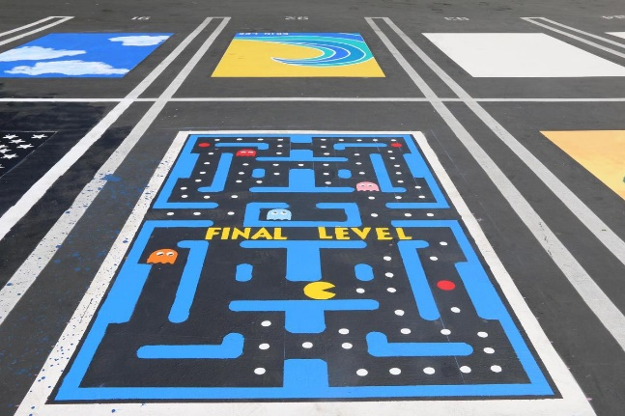

Benjamin Russell High School
Senior Painted Parking Spot Contract

Name: ________________________ Parking Permit# ____
Student cell #: __________________ License Plate #: ____

I HEREBY AGREE TO ABIDE BY ALL OF THE FOLLOWING RULES AND REGULATIONS CORRESPONDING TO MY PRIVILEGE OF HAVING A RESERVED PAINTED PARKING SPOT:
I will use WATER-BASED INTERIOR OR EXTERIOR LATEX PAINT.
I will not use reflective paint, fluorescent paint, or spray paint.
I will only paint within the parking spot that I am assigned.
I will paint within a neat 8” unpainted border of my parking spot.
I will not paint over the border or the parking spot number.
I understand that I must provide my own paint and painting supplies.
I will only paint school appropriate designs that have been pre-approved.
I will clean up all of my painting materials and trash when finished.
I understand that I may not park in someone else’s reserved parking spot.
I understand that I must repaint the parking spot black prior to Senior Awards Day.

If I do not abide by all of these rules, I understand that my parking spot will be taken away, painted over, and no refund.

____________________________ _______________________________
Senior Signature Parent Signature

Benjamin Russell High School

Name: ___________________________ Parking Permit# ____
Student cell #: ____________________
Student email: _____________________________________@acsk12.net

Please provide a detailed sketch in the space below of the design you would like to be approved. Your design must indicate all the colors you will use. You must maintain an 8” border between your design and the parking spot lines and numbers. Submit this sketch before August 23th to Mr. McGhee. He will keep your copy, so keep a copy or take a picture!!!
REMEMBER: 8” Unpainted Border

BE CREATIVE! MAKE IT MEMORABLE! HAVE FUN!

